

The SETI Institute: SEN sheet ANSWERS
Search for Extra-Terrestrial Intelligence

Is there anyone out there? The SETI Institute was set up to find out.

There doesn’t seem to be any other civilisation in our solar system. This means that if there are any aliens, they must be a LONG way away, on a planet that orbits another star.
- The chances of finding aliens we can talk to are low, because:
- __very few stars have suitable planets
- __very few of those may have any life
- __very few of those may have intelligent life
- __very few of those may have intelligent life NOW
- Using spaceships to find aliens (or for them to find us) is a lousy idea because:
- _ridiculously long journey times___
- _we (or they) don’t know where to head for
- Using telescopes to look for aliens doesn’t work too well, because:
  - _We don’t know where to look – there’s a LOT of sky
  - _Light is blocked by gas & dust_
- (a) So what do we use to look for intelligent aliens? _Radio telescopes_
(b) Why?
- _Radio waves can be sent out in a wide beam
- Radio waves can cross huge distances_____
6. Where is this dish?
_Arecibo, Puerto Rico_

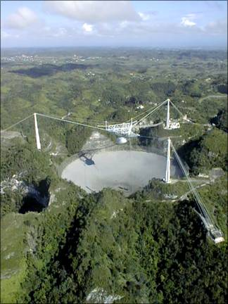

- Where is this dish?
_Jodrell Bank, Cheshire, England

