

The SETI Institute: SEN sheet
Search for Extra-Terrestrial Intelligence

Is there anyone out there? The SETI Institute was set up to find out.

There doesn’t seem to be any other civilisation in our solar system. This means that if there are any aliens, they must be a LONG way away, on a planet that orbits another star.
- The chances of finding aliens we can talk to are low, because:
- _____________________________________
- _____________________________________
- _____________________________________
- _____________________________________
- Using spaceships to find aliens (or for them to find us) is a lousy idea because:
- _____________________________________
- _____________________________________
- Using telescopes to look for aliens doesn’t work too well, because:
  - _____________________________________
  - _____________________________________
- (a) So what do we use to look for intelligent aliens? __________________
(b) Why?
- _____________________________________
- _____________________________________
6. Where is this dish?
_______________________

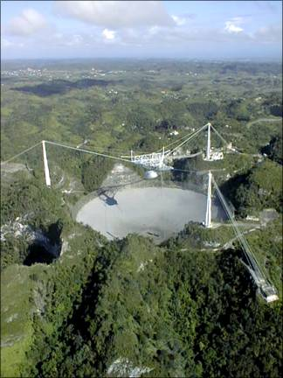

- Where is this dish?
_______________________

