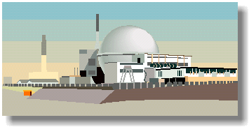
Nuclear Power Summary

Nuclear power is generated using Uranium, which is a metal mined in various parts of the world.

The first large-scale nuclear power station opened at Calder Hall in Cumbria, England, in 1956.

Some military ships and submarines have nuclear power plants for engines.

How it Works

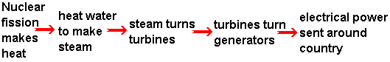

Nuclear power stations work in pretty much the same way as fossil fuel-burning stations, except that a "chain reaction" inside a nuclear reactor makes the heat instead.

The reactor uses Uranium rods as fuel, and the heat is generated by nuclear fission. Neutrons smash into the nucleus of the uranium atoms, which split roughly in half and release energy in the form of heat.

Carbon dioxide gas is pumped through the reactor to take the heat away, and the hot gas then heats water to make steam.

The steam drives turbines which drive generators.
Modern nuclear power stations use the same type of turbines and generators as conventional power stations.

Advantages  Nuclear power costs about the same as coal, so it's not expensive to make.  Does not produce smoke or carbon dioxide, so it does not contribute to the greenhouse effect.  Produces huge amounts of energy from small amounts of fuel.  Produces small amounts of waste.  Nuclear power is reliable. | Disadvantages  Although not much waste is produced, it is very, very dangerous.  It must be sealed up and buried for many years to allow the radioactivity to die away.  Nuclear power is reliable, but a lot of money has to be spent on safety - if it does go wrong, a nuclear accident can be a major disaster. people are increasingly concerned about this - in the 1990's nuclear power was the fastest-growing source of power in much of the world. Now, in 2005 it's the second slowest-growing.

Use these words to answer the questions: Nuclear burn chain dangerous energy no reactor robot rods shielding turbines uranium waste water

- Is nuclear power renewable? [yes/no] .
- Nuclear power stations use___________ as fuel. They need very little, compared to a "fossil" power station because there is much more ______________ in nuclear fuel.
- The __________ reaction inside the ___________ creates heat, which turns ________ into steam to drive __________, which drive generators to make electricity.
- The fuel ______ are safe to handle before they go into the reactor, it's only when they come out that you need to handle them with ___________ arms and heavy ________.
- __________ power stations do not create atmospheric pollution, because they do not ______anything. However, the small amount of _________ that they do produce is very __________.

