Analogue and Digital Signals
Words to use (you can use them more than once):
digital receiver weaker noise amplify signal clean
The problem with analogue signals is__________– hiss on the sound and speckly dots on the picture.
When we send a signal over a long distance, the signal gets ________, so we need to boost (_______) it.
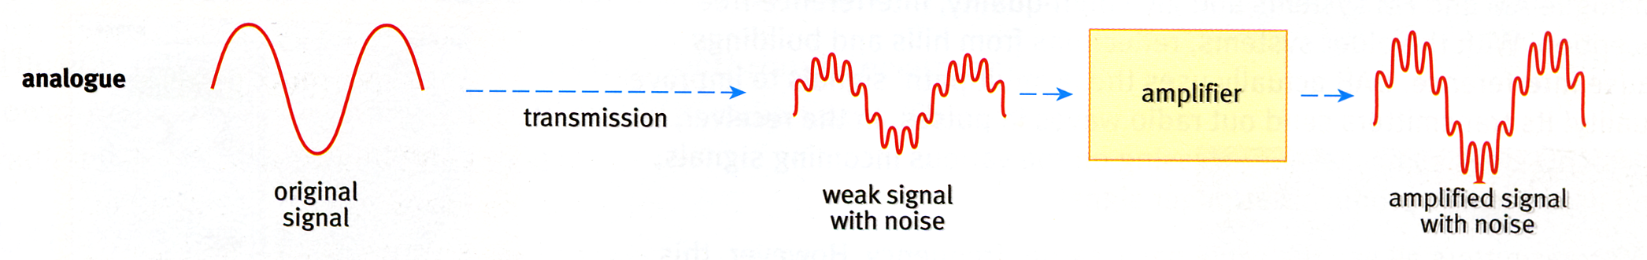
The problem is that we end up boosting the _______ as well.

If we convert the signal into _________ form, then send it, it still gets weaker and ______ still creeps in.
However, because it’s digital, the ________ can work out what the signal is supposed to look like behind all that noise, and reconstruct a “_______” signal.
So we don’t end up boosting the noise along with the________. This is why you get such good pictures on your digital satellite TV.
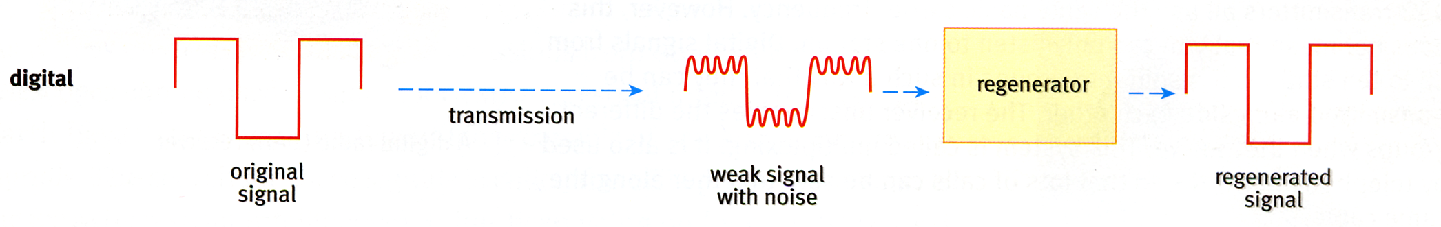
To convert a signal into digital form, we need to ‘sample’ it. The more we sample it the more ‘faithful’ the digital version is, but the bigger the file size & data rate needed.

