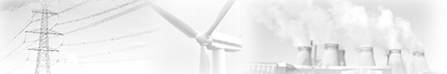
Energy Resources

Name _______________________________ Date ___/___/______

Go to www.darvill.clara.net/altenerg and fill in this table:-

 | Summarise the “Summary” | Your Quiz score (%)
Home page

Fossil Fuels
(Coal, Oil, Gas)

Nuclear Power
(Uranium)

Solar Power

Wind Power

Tidal Power

Hydro-electric Power

Pumped Storage Reservoirs
Wave Power

Geothermal Power

Biomass, Biogas and Biofuels

