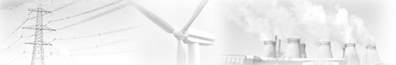

Name________________ Date ___/___/____
Energy Resources: GCSE

This is the minimum information you’ll need for Foundation GCSE.

Go to www.darvill.clara.net/altenerg and fill in this table:-

 | How it works | Advantages | Disadvantages | Renewable? [yes/no]
Fossil Fuels
(coal, oil, gas)

Nuclear Power
(uranium)

Solar power | 1.  2.  3.
Wind Power

Tidal Power

Hydro-electric
Power

Pumped Storage Reservoirs

Wave Power

Geothermal Power

Biomass, Biogas and Biofuels

